Ghazian Progress Report

York University, Toronto, ON

Spring 2020

**Micro to macroclimatic scaling effects on foundation plant species interaction with vertebrate protégé species.**

**Examination Committee:**

Dr. Christopher Lortie

Dr. Suzanne MacDonald

Table 1. MSc research timeline.

|  |  |  |
| --- | --- | --- |
| Chapter | Title | timeline |
| 1 | **A picture is worth a thousand hours: a systematic review of camera trap papers to test for reported sampling effort.** | Full-text articles assessed for eligibility.  Data extraction completed.  Data analysis in April-May.  Use as intro to thesis. |
| 2 | **Plant-animal interactions and microclimate.** | Field season done 15/05/2019-15/06/2019.  Carrizo camera traps processed.  Panoche camera traps processed.  Data analysis should start following the completion of the second manuscript of chapter 3. |
| 3 | **Effects of artificial shelters on canopy microclimate in arid and semi-arid regions: a potential tool for conservation.** | Field season done 15/05/2019-15/06/2019.  Data analyses completed.  First manuscript written by NG and edited by CJL.  Currently revising based on edits and writing second version.  Shrub and open data added.  Process shelter-open camera traps and add to analysis. |

**Background**

The Stress Gradient Hypothesis (SGH) proposes a switch from competition to facilitation with increasingly stressful environmental conditions (Bertness and Callaway 1994). This hypothesis sparked the interest of many (McIntire and Fajardo 2014; Fajardo and McIntire 2010) for examining positive interactions. Since, various studies have focused on positive interactions in harsh environments, including arid ecosystems (Maestre et al. 2009; Michalet et al. 2014; Lu et al. 2018). Facilitation is a type of positive interaction where one interacting species benefits whilst none are harmed (Bertness and Leonard 1997). Thus, positive interactions are studied relatively well when discussing stress; however, many do not measure and report stress effectively. Climate in particular is a stressor typically not explored, nor reported. Thus, to ideally advance the relative importance in stress with global change, we need to measure interactions and climate at different scales.

The type of vegetation that covers a terrestrial habitat is an important characteristic that can influence: foraging site selection(Thiele, Jeltsch, and Blaum 2008), reproduction(Thyen and Exo 2005), predator-prey interaction(Barbosa and Castellanos 2005), and thermoregulation (Parmenter and MacMahon 1983). Many of the above can be classified as a positive interaction between the vegetation and beneficiary species. Foundational plant species or nurse plants are an integral part of facilitation research (Filazzola and Lortie 2014). These include shrubs, perennials, trees, or cushion plants that benefit protégé species (Gómez-Aparicio et al. 2004) through various mechanistic pathways that include, but are not limited to, seed trapping, abiotic stress amelioration, and soil modification (Filazzola and Lortie 2014). There is also capacity for the same interaction pathways to benefit animals in deserts (Lortie, Filazzola, and Sotomayor 2016a). An important agent of abiotic stress amelioration is shrub canopy, able to facilitate animals through direct and indirect shelter and refuge effects (Lortie et al. 2018; Bråthen and Lortie 2016). Shrubs fulfil a critical functional role; hence, more species are associated with shrubs than open spaces (Lortie, Filazzola, and Sotomayor 2016b). This is evident in many lizards species such as *G. sila* that are found in shrubs in high afternoon temperatures (Westphal et al. 2018). The state of California is home to many diverse landscapes, many of which are dominated by a magnificent variety of shrubs (Stuart and Sawyer 2001). Species such as *Ephedra californica* (Mormon Tea) are known to be foundational plants, able to provide a variety of benefits to protégé species. It’s thus important to study these structural agents of facilitation as deserts are home to many rare, endemic species of animals that are federally listed as endangered (Ivey et al. 2020).

As the rate of anthropogenic climate change increases, many arid and semi-arid regions in the Western United States face extensive ecological shifts as a consequence (Abatzoglou and Kolden 2011). Factors such as land-use change, including agriculture in drylands (Schoups et al. 2005), can further decrease biodiversity by reducing the available terrestrial habitant for plants and for animals(Nopper et al. 2018; Elmqvist 2013; Irwin et al. 2010). In deserts, animals will not only experience large scale changes such as drought but also small scale changes such relatively more extreme fluctuations in temperature and light(Kikvidze et al. 2011; Titus, Nowak, and Smith 2002; Pianka 1966). This evidence suggests that not only do gross, large-scales changes in climate exert pressure on communities and sensitive species in drylands, but fine-scale changes and fluctuations can potentially further exasperate loss. Hence, in order to mitigate some of the impacts of anthropogenic disturbance, it’s not only important to explore the ameliorating benefits of natural vegetation, but it’s also crucial to find modes of conservation/restoration whilst new shrubs are grown and landscape recovery is made.

Artificial canopies, such as rainout shelters and Open-Top-Chambers (OTC), have been used to study the change in a variety of abiotic parameters such as CO2, temperature, soil temperature, solar radiation, and humidity (Berry et al. 2016; Yahdjian and Sala 2002). Although these shelters are effective, they’re relatively expensive to build and may be difficult to assemble in a short period of time. Rainout shelters used in semi-desert grassland studies have proven to be effective in altering precipitation, yet they have minimal impact on changing other variables such as air and soil temperature, humidity, and light (English et al. 2005). A cheaper alternative that is pioneered in this study is UV Permeable Shade Cloth Shelters (UPSS) made with PVC pipe skeleton and shade cloth cover. The landscape alongside the climate of southern California provides us with the opportunity to explore the effects these man-made shelters have on temperature and light intensity in a relatively inexpensive manner, using materials that can be easily assembled in the field.

**Chapter 1:** **A picture is worth a thousand hours: a systematic review of camera trap papers to test for reported sampling effort.**

**Purpose:** Identify the relevant literature using camera trapping to examine species richness and diversity as an index of sampling effort.

**Questions:** How many hours, days, or months are needed to estimate the species richness and diversity of a given ecosystem using a camera trapping tool? What taxa are usually recorded (i.e. mammals, aves etc.)? Do abiotic parameters such as temperature function as a covariate when predicting species richness?

**Methods:** The PRISMA diagram (Figure 1) workflow describes the process of this meta-analysis. A citation alert set up on Web of Science with key terms ensures that the review is up to date. Studies were selected from a scientific database (Web of Science) using the keywords: Camera Trap* AND Richness*, Camera* Trap* AND Diversity*, and Camera Trap* AND Rarefaction* Curve*. This search was done on January 27th, 2019. An entire paper was selected for the analysis if it contained the species richness/diversity and at least some sort of a measurement of time spam (hours, days, months, and/or camera trapping days), in addition to the number of records. If the study reported a measure of temperature, this was recorded; however, most studies did not. Thus, external research needs to be done in order to obtain climate data. Exclusion criteria included non-English, reviews or idea papers, non-quantitative studies, or focussed on a single species.

**Results:** A total of 515 studies were selected, which resulted in 397 studies when duplicates were removed. Many of the papers were either long-term, wildlife monitoring studies or agricultural. However, infrequently there were some studies involving aquatic ecosystems and coral reefs.

**Progress to Date:** Data extraction is finished. A total of 119 papers (some with multiple trial years) were included in the study.

**Future Direction:** clean up data and do some statistical analyses and use information as an intro to thesis.

Papers obtained through database searching (Web of Science) Keywords:

Camera* Trap* AND Richness*, Diversity*, and Rarefaction* Curve*

(n= 515)

(n = 1090)

Records after duplicates removed   
(n = 397)

## Identification

Papers obtained from other sources, such as book chapter bibliographies

(n= 0)

## Eligibility

Records excluded for: relevance, review, opinion or idea paper, focus on one spices, qualitative, not English.

Records screened by abstract (n = 397)

## Screening

Full-text articles assessed for eligibility (n = 252)

(n = )

Full-text articles excluded:

Not reporting richness or diversity, number of records, and any measure of duration.

Include in synthesis

(n = 119)

## Included

Extracted data:

Location (latitude, longitude), duration in hours, duration in months, camera trap days, number of records, animal richness, common name, scientific name, year, number of cameras, presence of bait, number of sites, month of study, type of ecosystem, study design, mean annual temperature, mean temperature of study period, max temperature

Figure 1: PRISMA diagram used for camera trapping effort systematic review (Moher et al. 2009). Search done with keywords: Camera* Trap* AND Richness*, Diversity*, and Rarefaction* Curve* on January 27th, 2019.

**Chapter 2: Plant-animal interactions and microclimate.**

**Purpose:** To examine whether animal association patterns with shrubs are explained by microsite level fluctuations in temperature and light.

**Question:** To what extent do radiation intensity, air, and soil temperature influence the association of vertebrates with foundational plants? How does the strength of this association change as the above microclimatic parameters increase or decrease? Is this association species-specific and does it depend on the animal’s lifestyle?

**Hypotheses:** Shrubs act as thermal refuges for many desert animals by reducing temperature, reducing the amplitude of variation in mircoclimate, and providing refuge from direct sunlight.

**Predictions:**

1. There are more animals associated with shrubs relative to open, non-canopy sites and the strength of this relationship increases with micro-environmental stress.
2. Shrub size predicts the strength of association between shrubs and protégé animals.
3. The facilitation refuge effect may be enhanced between abundance and richness of animal populations.
4. Microclimatic (ones site) and mesoclimatic (multiple sites) measures are more significant predictors of fine-scale animal abundances relative to the macroclimate of the region.

**Methods:**

A total of 2 sets of temperature pendant loggers (one soil and one air) was placed below the canopy for shrub microsite and 3 meters away from the camera in the open for the open microsite to log temperature and light intensity data in 1 hour intervals. The air pendants were secured to pegs using zip ties and placed ~10cm above ground, to avoid the influence of soil temperature. Camera trapping began May 17th, 2019 and ran until June 6th, 2019 in the Carrizo National Monument at 2 different sites, and lasted from May 20th to May 27th, 2019 in Panoche Hills. Cameras were re-deployed at a new shrub on a 4 day basis to avoid repeated-measures sampling. New shrubs were randomly selected, however a comparison of previous coordinates with new coordinates ensured than no shrub was selected more than once. However, due to the large distance between sites, this was not possible at Panoche; hence, all cameras were deployed with new batteries that ensured a total week of trapping, as the site could not be maintained on a 4 day basis. Each camera was deployed facing a shrub 3 meters away from shrub canopy. The open microsite equivalent was placed back-to-back with the shrub camera, but recording the open/non-canopy area. Shrub height, length, and width (x, y, and z) dimensions were also recorded. Cameras were placed exactly at ground level at any given coordinate and secured to the ground using pegs. Additionally, Soil moisture measurements were recorded under the canopy and in the open (directly beside the camera) upon deployment. There were a total of 9 microsites in Carrizo- five in mesosite 3 and four in mesosite 4. There was one mesosite in Panoche that had a total of 7 camera microsites. Images collected were saved as Joint Photographic Expert Group (JPEG) format where data such as presence/absence of an animal were extracted as a binary variable (0’s and 1’s). Additional data such as animal binary name, as well as replicate numbers were also recorded.

**Progress to Date:**

* Field season was successfully completed.
* Camera trap imagery data from both location have been processed: ~10,000 in each location.
* HOBO Onset temperature/light data have been downloaded.
* Microclimate data for Panoche have been downloaded from Los Baños Weather Station, <http://www.usclimatedata.com/> and visualized using various plots.
* Logger data are a good predictor of fine-scale temperature and intensity changes.
* Many similarities between macro and microclimate data when visualized.

**Future Direction:**

* Proposed idea: combined 2nd and 3rd chapter for a stronger thesis- to be discussed during the presentation.
* Test how effective shrubs are versus shelters versus the open in reducing the mean variation in light and temperature.
* Test how effective shelter is versus shrub versus the open at attracting vertebrates
  + Process camera traps from shelter-open pairs at Panoche and compare to shrub-pair camera traps to test for species richness and diversity near these microsites.
  + Camera trapping was done at 12 shelters with the camera being set up 3 meters away from the shelter.
  + The shelter camera was facing the shelter, while the open equivalent faced the open.
  + Open pendant was set up beside the camera on a peg as described in the methods above.
  + Shelter pendant was placed directly underneath the shelter, secured to a peg.

**Chapter 3: Effects of artificial shelters on canopy microclimate in arid and semi-arid regions: a potential tool for conservation.**

**Purpose:** To describe the methodology of constructing artificial UV shelters for drylands, as well as exploring effects on canopy microclimate, including light and temperature.

**Questions:** How does percent coverage of shelter material influence canopy microclimate? To what extent does shape matter when it comes to temperature and light intensity? What are the implication of this study for different climate change scenarios? Can these shelters be used as a mode of conservation/restoration post anthropogenic disturbance? How do shelters compare with shrubs in reducing temperature and light intensity under their canopy?

**Hypotheses and predictions:**

1. Shelters have the ability to reduce mean variation of light and temperature.
2. Shelters offer a more consistent microclimate relative to the open.
3. Shaded microhabitats, such as those of shelters, increase the thermal heterogeneity of the landscape for a variety of animals.
4. The 90% UV blockage is best at ameliorating canopy microclimate as it blocks the most amount of direct sunlight and reduces temperature.
5. Shape can have a significant effect on microclimate.

**Materials & Methods:**

***Study site***

This study was conducted in Panoche Hills Management Area located on the western edge of the San Joaquin Valley, California (Bureau of Land Management; 36◦41.78′ N, 120◦47.89′ W). The region’s climate can be characterized as arid/semi-arid. The average annual precipitation is 25.5 cm with an annual low and high temperature of 10.4 ºC and 76.3 ºC, respectively. Winter and fall are considered to be the wettest seasons. The mean temperature observed in May is 20.4 ºC and 23.7 ºC in June (Los Baños Weather Station, <http://www.usclimatedata.com/>).

The region is heavily dominated by invasive grasses such as: *Bromus madritensis ssp. Rubens, Bromus hordeaceus, Erodium cicutarium* and *Schismus barbatus*(Filazzola et al. 2017)*.*

***Shelter Construction***

Shelters were constructed using PVC piping and UV permeable shade cloths at three light blockage intensities: 15%, 50%, and 90%. The open (no structure) at 0% light blockage served as control. The cloths were attached to the PVC using zip ties. Table 1 describes the number of pieces at specific dimensions and diameter needed to build each triangle or square shelter. There were six replicates of each shape-two pertaining to each blockage percentage-for a total of 12 replicates. Pipes were slid onto metal stakes, which were hammered into ground for stability. Latitude and longitude coordinates of each shelter-open pair was also recorded. Rectangular (referred to as square in stats) shelters consisted of two sides with two 61 cm ½ inch pipes facing the ground connected to a 61 cm ¾ inch pipe using a 90º elbow. Triangular shelters were built using a 75 cm ¾ inch top pipe connected to a ½ inch to ¾ inch adapter. The adapter was then attached to a ½ inch 3-way 90º elbow fitted with two 61 cm ½ pipes. Cloths were used to cover two side of the triangular shelters and three sides of the rectangular shelters. Shelters were visited on a weekly basis throughout deployment.

**Table 1.** A list of PVC pieces used for shelter skeleton construction is provided alongside the quantity needed to build one of each shelter-type.

|  |  |  |
| --- | --- | --- |
| Piece | Quantity for Triangular Shelter | Quantity for Rectangular Shelter |
| 61 cm (½ inch diameter) pipe | 4 | 4 |
| 61 cm (¾ inch diameter) pipe | NA | 2 |
| 75 ¾ cm pipe | 1 | NA |
| ½ inch to ¾ inch adapter | 2 | NA |
| ½ inch to ¾ inch 2-way 90º elbow | NA | 4 |
| ½ inch 3-way 90º elbow | 2 | NA |

***Abiotic Measurements***

To measure the difference in light and temperature within shelters and between shelters and open microsites, Onset HOBO Temperature/Light Pendant (8K) loggers were placed inside and directly outside to the right of the shelters. A total of 24 pendants were used, where each pendant was tied to a plastic stake using a zip tie. Stakes were hammered into the ground until stable with ~10 cm remaining above ground. This was to done to ensure that logger data were not influence by ground cover and true ambient conditions both inside and outside were recorded. Air temperature (ºF) and light intensity (lum/ft2) were recorded hourly. Loggers were placed out mid-May (20th) and collected in mid-June (12th), 2019 to represent spring-summer seasonal variation. Data collected were then categorized into time blocks: morning (6 AM-11:59 PM), afternoon (12 PM-11:59 PM), and evening (12:00AM-5:59AM).

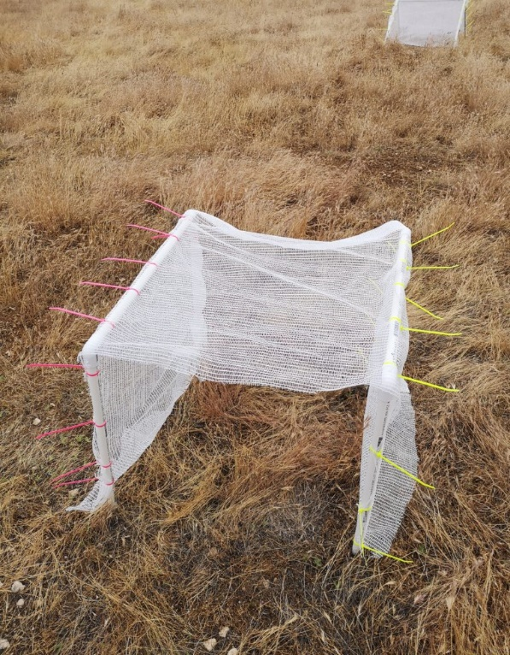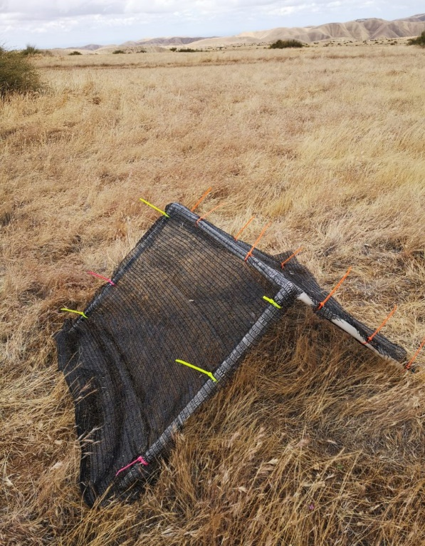

**Figure 2.** Left-Triangular shelter with 90% shade cloth attached to PVC skeleton using zip ties. Right-Rectangular shelter with 15% shade cloth attached to two PVC skeletal frames.

**Preliminary Results:**

* There are significant differences between shelters (square and triangle), shrubs, and the open in regards to temperature and light intensity (p<0).
* The open showed the most variation in data.
* There is a positive relationship between light and temperature regardless of the time of the day
* Triangle was also superior to rectangle when it came to lowering the light intensity. At 50% and 90% blockage triangle showed to more effective at controlling incoming light, regardless of the time of the day (p<0.001).
* Rectangle was better at reducing incoming light at 15% light blockage.

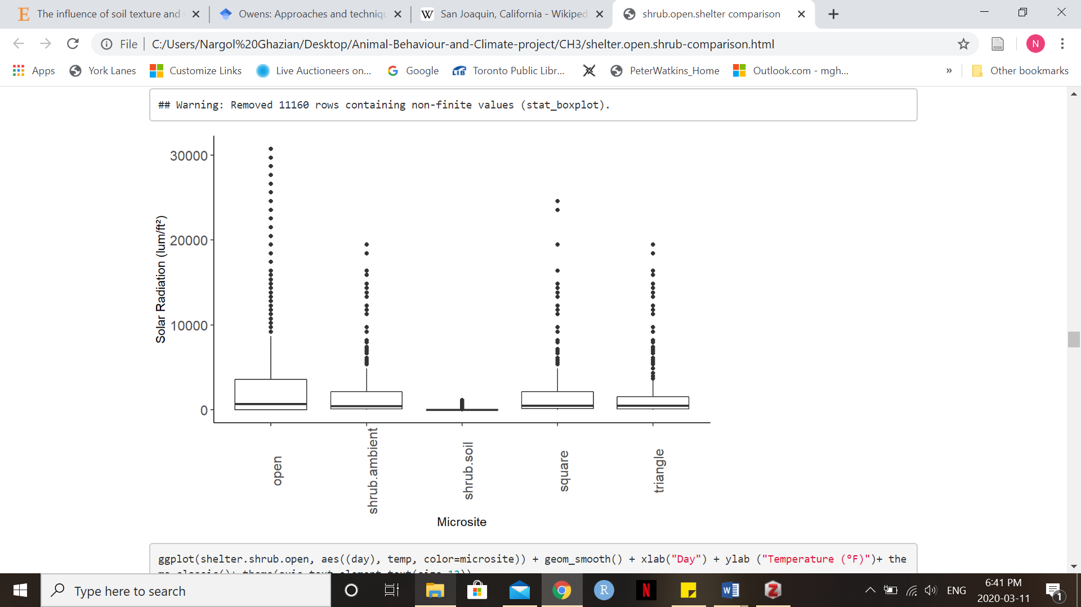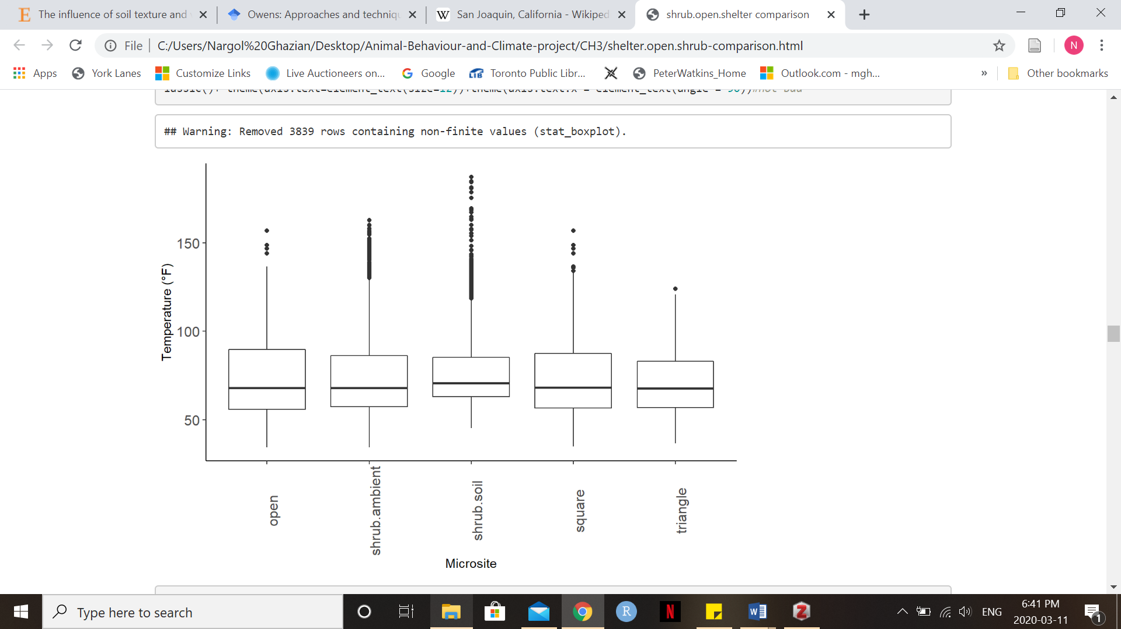

**Figure 3.** The relationship between temperature (ºF) and light intensity/solar radiation (lum/ft2) are shown at the different microsites. Solid middle lines shows the median of the data, whilst whiskers show 1.5 standard deviation. Solid dots are outliers >1.5 interquartile range (IQR).

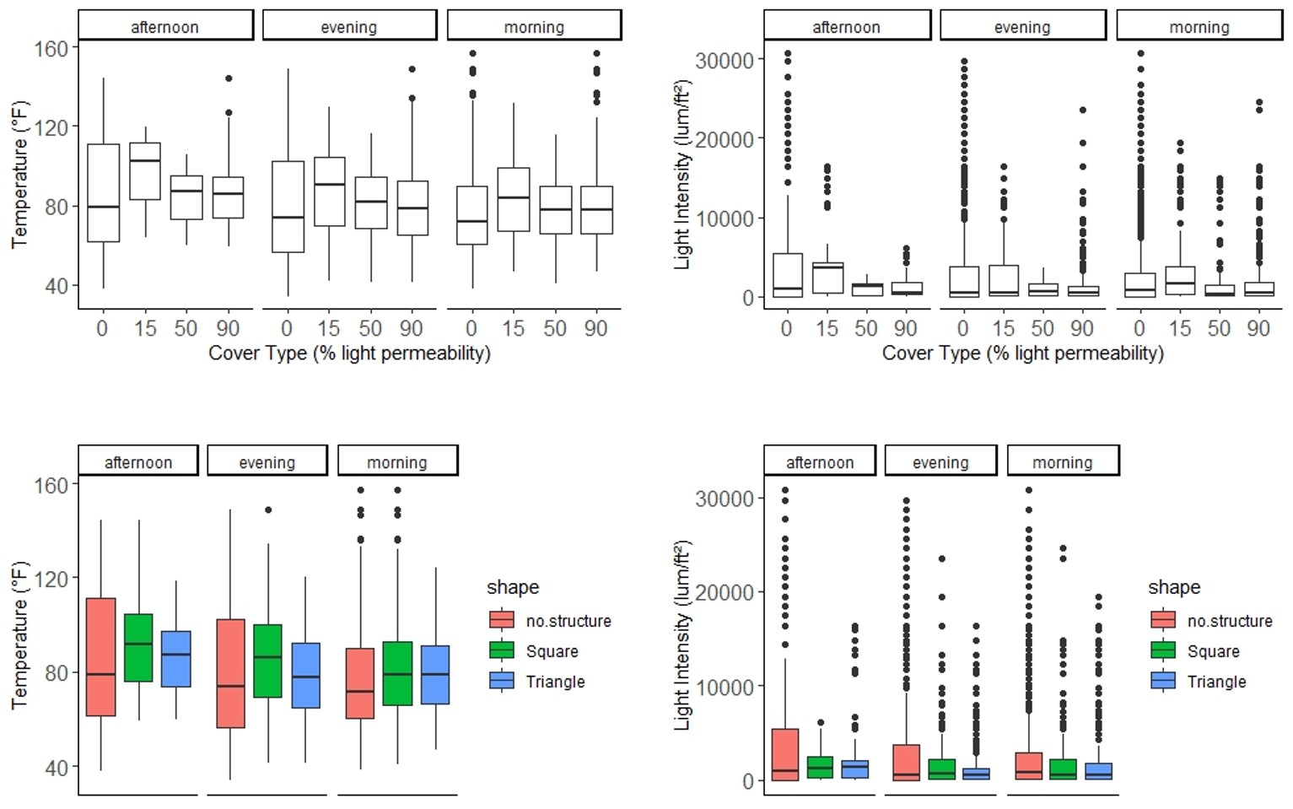

**Figure 4.** The relationship between temperature (ºF) and the different blockage intensities and shape for the three time blocks. No structure simply means open. These relationships are also shown for light intensity (lum/ft2). Solid middle lines shows the median of the data, whilst whiskers show 1.5 standard deviation. Solid dots are outliers >1.5 interquartile range (IQR).

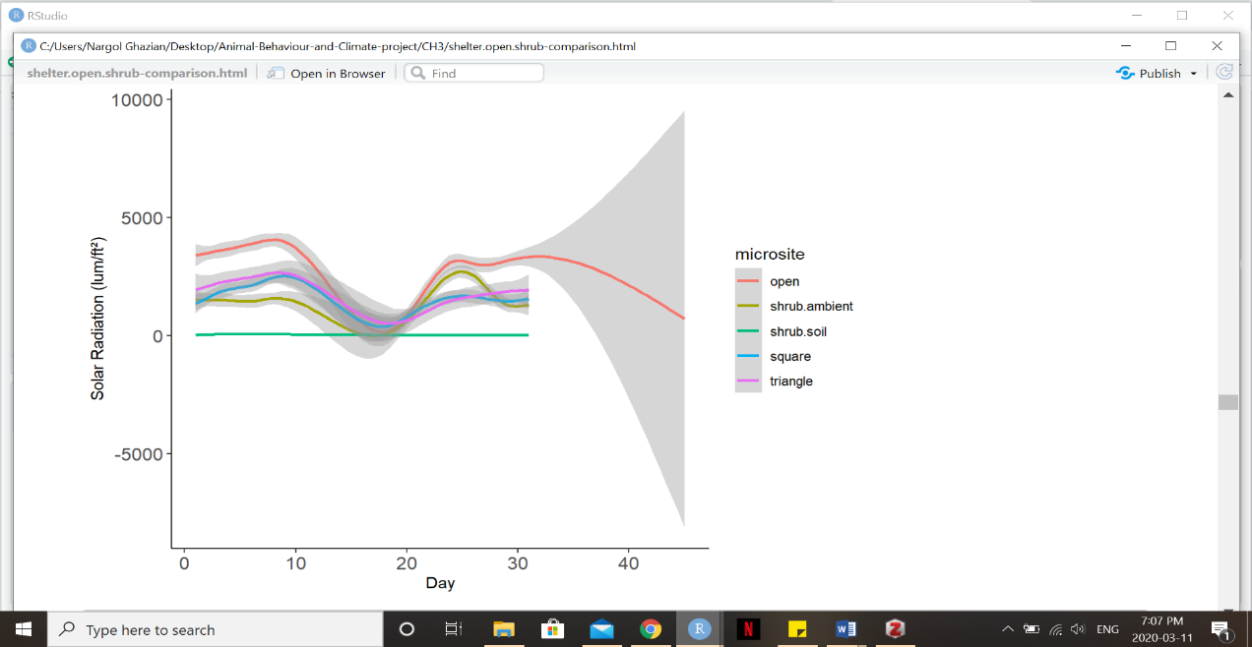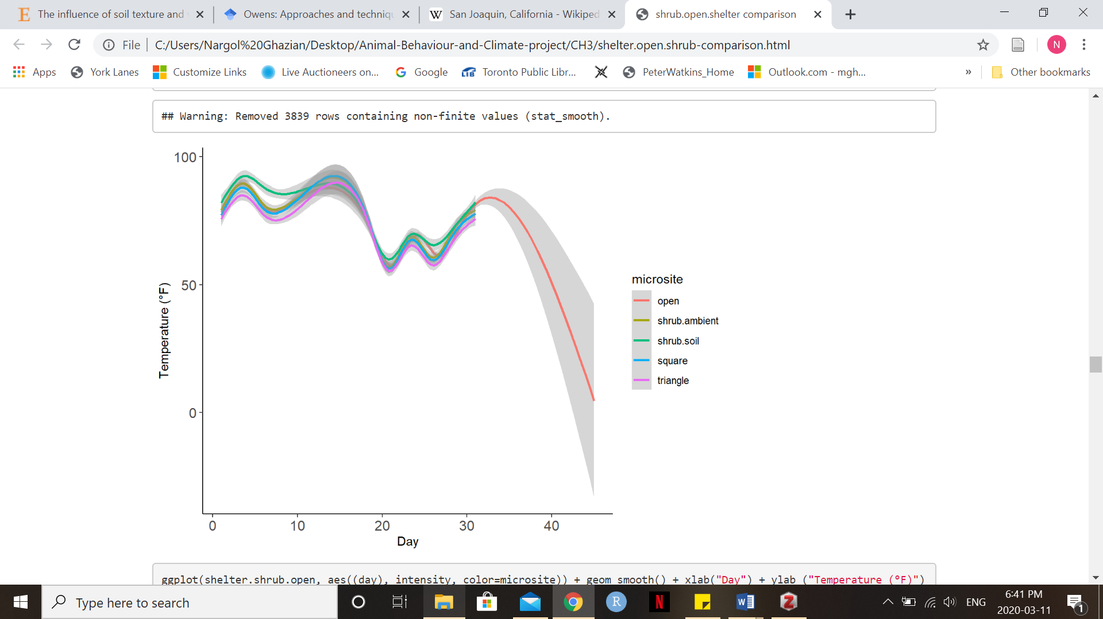

**Figure 5.** Smooth density plots showing the fluctuations in temperature (ºF) and solar radiation (lum/ft2) throughout the duaration of the study.

**Future Direction:**

* Test variation (Coefficient of Variation) for light and temperature at each of the microsites and find a meaningful way to present on a plot
* Red-do a figure similar to Figure 4, though include shrub.open and shrub.soil.
* Do more pairwise analysis and update tables submitted in the first manuscript to CJL.
* Discuss with CJL and SM on what is the story we’re trying to tell and what figure(s) best tell that story.
* Perhaps combine with chapter 2 and add animal camera trap data at shelters and at shrubs.
* Maybe include Residual Dry Matter (RDM) data.

**Questions for Committee:**

1. Should we combine chapter 2 and chapter 3 for a single paper, yet stronger thesis?
2. What’s the best way to present variation?
3. Are histogram mean, median plots a good figure (in slide deck)?
4. Do we need to do another field season?
5. How do we tie macroclimate data/figures (in slide deck) to the rest of the paper?

**Work Cited**

Abatzoglou, John T., and Crystal A. Kolden. 2011. “Climate Change in Western US Deserts: Potential for Increased Wildfire and Invasive Annual Grasses.” *Rangeland Ecology & Management* 64 (5): 471–78. https://doi.org/10.2111/REM-D-09-00151.1.

Barbosa, Pedro, and Ignacio Castellanos, eds. 2005. *Ecology of Predator-Prey Interactions*. Oxford ; New York: Oxford University Press.

Berry, Kristin H., James F. Weigand, Timothy A. Gowan, and Jeremy S. Mack. 2016. “Bidirectional Recovery Patterns of Mojave Desert Vegetation in an Aqueduct Pipeline Corridor after 36 Years: I. Perennial Shrubs and Grasses.” *Journal of Arid Environments* 124 (January): 413–25. https://doi.org/10.1016/j.jaridenv.2015.03.004.

Bertness, Mark D., and Ragan Callaway. 1994. “Positive Interactions in Communities.” *Trends in Ecology & Evolution* 9 (5): 191–93. https://doi.org/10.1016/0169-5347(94)90088-4.

Bertness, Mark D., and George H. Leonard. 1997. “the role of positive interactions in communities: lessons from intertidal habitats.” *Ecology* 78 (7): 1976–89. https://doi.org/10.1890/0012-9658(1997)078[1976:TROPII]2.0.CO;2.

Bråthen, Kari Anne, and Christopher Lortie. 2016. “A Portfolio Effect of Shrub Canopy Height on Species Richness in Both Stressful and Competitive Environments.” Edited by Richard Michalet. *Functional Ecology* 30 (1): 60–69. https://doi.org/10.1111/1365-2435.12458.

Elmqvist, Thomas, ed. 2013. *Urbanization, Biodiversity and Ecosystem Services: Challenges and Opportunities: A Global Assessment ; a Part of the Cities and Biodiversity Outlook Project*. Springer Open. Dordrecht: Springer.

English, N.B., J.F. Weltzin, A. Fravolini, L. Thomas, and D.G. Williams. 2005. “The Influence of Soil Texture and Vegetation on Soil Moisture under Rainout Shelters in a Semi-Desert Grassland.” *Journal of Arid Environments* 63 (1): 324–43. https://doi.org/10.1016/j.jaridenv.2005.03.013.

Fajardo, Alex, and Eliot J.B. McIntire. 2010. “Under Strong Niche Overlap Conspecifics Do Not Compete but Help Each Other to Survive: Facilitation at the Intraspecific Level: Intraspecific Facilitation in Nothofagus Pumilio.” *Journal of Ecology*, December, no-no. https://doi.org/10.1111/j.1365-2745.2010.01771.x.

Filazzola, Alessandro, and Christopher J. Lortie. 2014. “A Systematic Review and Conceptual Framework for the Mechanistic Pathways of Nurse Plants: A Systematic Review of Nurse-Plant Mechanisms.” *Global Ecology and Biogeography* 23 (12): 1335–45. https://doi.org/10.1111/geb.12202.

Filazzola, Alessandro, Michael Westphal, Michael Powers, Amanda Rae Liczner, Deborah A. (Smith) Woollett, Brent Johnson, and Christopher J. Lortie. 2017. “Non-Trophic Interactions in Deserts: Facilitation, Interference, and an Endangered Lizard Species.” *Basic and Applied Ecology* 20 (May): 51–61. https://doi.org/10.1016/j.baae.2017.01.002.

Gómez-Aparicio, Lorena, Regino Zamora, Jose M. Gómez, Jose A. Hódar, Jorge Castro, and Elena Baraza. 2004. “Applying plant facilitation to forest restoration: a meta-analysis of the use of shrubs as nurse plants.” *Ecological Applications* 14 (4): 1128–38. https://doi.org/10.1890/03-5084.

Irwin, Mitchell T., Patricia C. Wright, Christopher Birkinshaw, Brian L. Fisher, Charlie J. Gardner, Julian Glos, Steven M. Goodman, et al. 2010. “Patterns of Species Change in Anthropogenically Disturbed Forests of Madagascar.” *Biological Conservation* 143 (10): 2351–62. https://doi.org/10.1016/j.biocon.2010.01.023.

Ivey, Kathleen N, Margaret Cornwall, Hayley Crowell, Nargol Ghazian, Emmeleia Nix, Malory Owen, Mario Zuliani, Christopher J Lortie, Michael Westphal, and Emily Taylor. 2020. “Thermal Ecology of the Federally Endangered Blunt-Nosed Leopard Lizard (Gambelia Sila).” Edited by Steven Cooke. *Conservation Physiology* 8 (1): coaa014. https://doi.org/10.1093/conphys/coaa014.

Kikvidze, Zaal, Richard Michalet, Rob W. Brooker, Lohengrin A. Cavieres, Christopher J. Lortie, Francisco I. Pugnaire, and Ragan M. Callaway. 2011. “Climatic Drivers of Plant–Plant Interactions and Diversity in Alpine Communities.” *Alpine Botany* 121 (1): 63–70. https://doi.org/10.1007/s00035-010-0085-x.

Lortie, Christopher J., Alessandro Filazzola, and Diego A. Sotomayor. 2016a. “Functional Assessment of Animal Interactions with Shrub-Facilitation Complexes: A Formal Synthesis and Conceptual Framework.” Edited by Richard Michalet. *Functional Ecology* 30 (1): 41–51. https://doi.org/10.1111/1365-2435.12530.

———. 2016b. “Functional Assessment of Animal Interactions with Shrub-Facilitation Complexes: A Formal Synthesis and Conceptual Framework.” Edited by Richard Michalet. *Functional Ecology* 30 (1): 41–51. https://doi.org/10.1111/1365-2435.12530.

Lortie, Christopher J., Eva Gruber, Alex Filazzola, Taylor Noble, and Michael Westphal. 2018. “The Groot Effect: Plant Facilitation and Desert Shrub Regrowth Following Extensive Damage.” *Ecology and Evolution* 8 (1): 706–15. https://doi.org/10.1002/ece3.3671.

Lu, Rong, Jiyong Zheng, Chao Jia, Yu Liu, Ze Huang, Honghua He, Fengpeng Han, and Gao-Lin Wu. 2018. “Nurse Effects of Patch-Canopy Microhabitats Promote Herbs Community Establishment in Sandy Land.” *Ecological Engineering* 118 (August): 126–33. https://doi.org/10.1016/j.ecoleng.2018.04.019.

Maestre, Fernando T., Ragan M. Callaway, Fernando Valladares, and Christopher J. Lortie. 2009. “Refining the Stress-Gradient Hypothesis for Competition and Facilitation in Plant Communities.” *Journal of Ecology* 97 (2): 199–205. https://doi.org/10.1111/j.1365-2745.2008.01476.x.

McIntire, Eliot J. B., and Alex Fajardo. 2014. “Facilitation as a Ubiquitous Driver of Biodiversity.” *New Phytologist* 201 (2): 403–16. https://doi.org/10.1111/nph.12478.

Michalet, Richard, Yoann Le Bagousse-Pinguet, Jean-Paul Maalouf, and Christopher J. Lortie. 2014. “Two Alternatives to the Stress-Gradient Hypothesis at the Edge of Life: The Collapse of Facilitation and the Switch from Facilitation to Competition.” Edited by Michael Palmer. *Journal of Vegetation Science* 25 (2): 609–13. https://doi.org/10.1111/jvs.12123.

Moher, David, Alessandro Liberati, Jennifer Tetzlaff, Douglas G. Altman, and The PRISMA Group. 2009. “Preferred Reporting Items for Systematic Reviews and Meta-Analyses: The PRISMA Statement.” *PLoS Medicine* 6 (7): e1000097. https://doi.org/10.1371/journal.pmed.1000097.

Nopper, Joachim, Jana C. Riemann, Katja Brinkmann, Mark-Oliver Rödel, and Jörg U. Ganzhorn. 2018. “Differences in Land Cover – Biodiversity Relationships Complicate the Assignment of Conservation Values in Human-Used Landscapes.” *Ecological Indicators* 90 (July): 112–19. https://doi.org/10.1016/j.ecolind.2018.02.004.

Parmenter, Robert R., and James A. MacMahon. 1983. “Factors Determining the Abundance and Distribution of Rodents in a Shrub-Steppe Ecosystem: The Role of Shrubs.” *Oecologia* 59 (2–3): 145–56. https://doi.org/10.1007/BF00378831.

Pianka, Eric R. 1966. “Convexity, Desert Lizards, and Spatial Heterogeneity.” *Ecology* 47 (6): 1055–59. https://doi.org/10.2307/1935656.

Schoups, G., J. W. Hopmans, C. A. Young, J. A. Vrugt, W. W. Wallender, K. K. Tanji, and S. Panday. 2005. “Sustainability of Irrigated Agriculture in the San Joaquin Valley, California.” *Proceedings of the National Academy of Sciences* 102 (43): 15352–56. https://doi.org/10.1073/pnas.0507723102.

Stuart, John David, and John O. Sawyer. 2001. *Trees and Shrubs of California*. California Natural History Guides 62. Berkeley: University of California Press.

Thiele, T., F. Jeltsch, and N. Blaum. 2008. “Importance of Woody Vegetation for Foraging Site Selection in the Southern Pied Babbler (Turdoides Bicolor) under Two Different Land Use Regimes.” *Journal of Arid Environments* 72 (4): 471–82. https://doi.org/10.1016/j.jaridenv.2007.06.011.

Thyen, S., and K.-M. Exo. 2005. “Interactive Effects of Time and Vegetation on Reproduction of Redshanks (Tringa Totanus) Breeding in Wadden Sea Salt Marshes.” *Journal of Ornithology* 146 (3): 215–25. https://doi.org/10.1007/s10336-005-0082-9.

Titus, Jonathan H., Robert S. Nowak, and Stanley D. Smith. 2002. “Soil Resource Heterogeneity in the Mojave Desert.” *Journal of Arid Environments* 52 (3): 269–92. https://doi.org/10.1006/jare.2002.1010.

Westphal, Michael F., Taylor Noble, Harry Scott Butterfield, and Christopher J. Lortie. 2018. “A Test of Desert Shrub Facilitation via Radiotelemetric Monitoring of a Diurnal Lizard.” *Ecology and Evolution* 8 (23): 12153–62. https://doi.org/10.1002/ece3.4673.

Yahdjian, Laura, and Osvaldo E. Sala. 2002. “A Rainout Shelter Design for Intercepting Different Amounts of Rainfall.” *Oecologia* 133 (2): 95–101. https://doi.org/10.1007/s00442-002-1024-3.